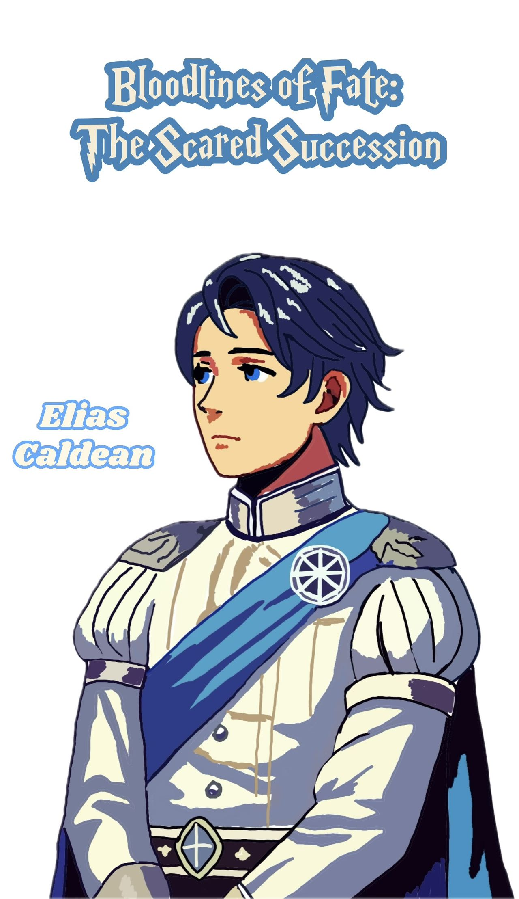

Elias Caldean Player Handbook
1. The setting of the story and the present
Tensions are always high on a land that is split between the Nagari Tribe, the Falor Theocracy, and the Caldean Kingdom. Noble blood is holy in the Caldean Kingdom, which is an absolute monarchy. The royal family keeps its power through the so-called "Blood of the King." We are now only ten days away from the next "Sacred Lion Succession Ceremony," where Prince Alfred will take the throne.
People who broke away from Caldean hundreds of years ago and fought for equality for everyone set up the Falor Theocracy. Even though people had good intentions, the reality of government shows unfairness and extremists within, and there are disagreements between the Pope and those in power.

The Nagari Tribe was made up of slaves who rose up against the Caldean Kingdom twenty years ago. They ran away into the forest and became a wandering group. They are still fighting for their freedom, and often run into Caldean troops.
2. Information about the player character
Who You Are:
Elias Caldean is the real heir to the Caldean throne. He is Leo Caldean's son. Your father, Prince Leo, found out the truth about the "Blood of the King" at the last "Sacred Lion Succession Ceremony." He could not stand the idea of lying to the people for power. He chose to leave the country and take you to the Falor Theocracy with him. You have lived in secret since then, away from the political fights at the royal court.
Background and past events:
Your early childhood in Caldean is a mix of comfort and dread. Even though you lived in a fancy castle, you felt like you were locked up. The lessons and training you got every day taught you that being a noble meant having a life full of duty and control, which you found tight. You heard your parents arguing late at night a lot. Your dad had doubts about the royal succession, and your mom was begging for the family's safety. You knew what it was like to be a royal child even when you were a kid.
All of that changed at the last gathering for succession. Your dad took you and ran away from Caldean that night. During the escape, you learned the real story behind "Blood of the King." It wasn't a divine power; it was a lie made up to keep people in line and protect royal power. Your dad would no longer put up with the lie, and he wanted you to have a life without lies and rules. After that, you were just a regular person living in Falor, not a prince anymore.
It wasn't easy to live in Falor. You saw that many of the Caldean refugees still had to deal with discrimination, even though they taught equality. Because of his skills, your father Leo slowly rose to power in Falor, but you noticed that he always stayed careful, on the lookout for Caldean spies. At first, you were hopeful about Falor's ideas, but as time went on, you started to wonder if there was really equality here. You learned that a lot of people in Falor had prejudices, especially against those who had run away from Caldean. You wanted to live a life without royal lies, but you still felt the stress of trying to fit in, which you couldn't get rid of.
You feel heavy because you know that the "Blood of the King" is a lie. It's a big secret that makes you think of how unfair things are for the people of Caldean because they believe lies. You often feel torn because you want to tell people the truth but are afraid of what will happen to you, your dad, and even Falor if you do.
There were times of comfort despite the hard times. You remember your dad's rare smiles when things went well, the simple meals you shared with him, and the nights when he told you stories about people who fought against oppression. Small joys like these kept you grounded and told you of why you were fighting: a world where no one lies.
3. How to Hide Things
Your real name must be kept secret. You are the true heir to the Caldean throne, and if people found out who you were, they might start chasing you and there might be trouble in Falor. It's also illegal to talk about the truth about the "Blood of the King." Although you think that people have the right to know, you can't take any risks right now because of how dangerous things are.
4. Thoughts on Other Player Characters
Alfred Caldean is your cousin. He is the son of King Edwin III and a strong belief in the "Blood of the King." His power and will come from the royal family. You feel sorry for him because he is caught up in the false power of the bloodline, but you also know that he is a tough opponent who will not hesitate to get rid of anyone who threatens his claim.
Not Selena Noth:
A very important person in Falor's network of spies who is very interested in the royal family's secrets. You stay away from her because you don't know how loyal she is, and her search for the truth could have unexpected effects on you and your dad.
Arya Amir is the daughter of the leader of the Nagari Tribe. You find it interesting that she wants to be free, and you kind of admire her. Her sincere behavior makes her seem like a possible friend, but her position could also make her a surprise in your search for the truth.
Gareth Reynolds: Your cousin's loyal guard, who stands for the royal family's love and power. Because he will always be loyal to Alfred, he is one of your biggest threats. His appearance always makes you think about how powerful the royal family is.
5. Goals for Character
The public goal is:
To live in secret under the protection of the Falor Theocracy and stay out of open conflict with Caldean.
Secret Goal: You want to find a way to show that the "Blood of the King" story is a lie and break Caldean's mental power over its people. You know, though, that doing something like that could put you and your dad in great danger. To bring the truth to light one day, you must carefully choose your partners while keeping safety in mind.

